Utah Inland Port Storm Water

Sampling and Analysis Plan

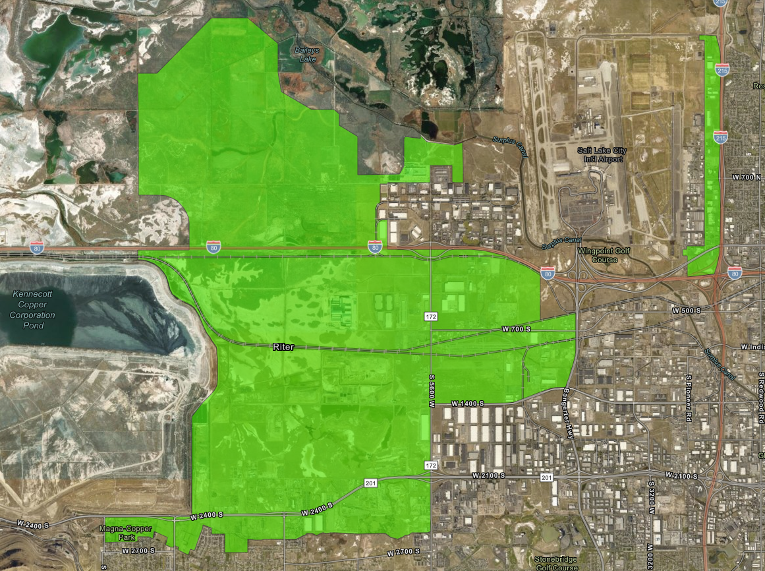
Revised May 2022

Contents
Introduction 1
Background 1
Site Description 1
Summary of Project Tasks and Schedule 3
Objectives and Design of the Study 4
Specific Objectives of the Study 4
Data Quality Objectives (DQOs) 5
Sample Design 7
Water Quality Characterization 7
Site descriptions and selection rationale 10
4991297 Storm Drain Channel at 8000 W North Temple 10
4991299 Storm Drain Channel at 7200 W and 1300 N 10
4991313 Storm Drain Channel at 150 S 5600 W 10
4991305 Storm Drain Channel at end of John Cannon Dr 10
4991302 Storm Drain Channel at 1100 N 6550 W 10
4991303 Storm Drain Channel at 6000 W 700 N 11
Measured Storm Water Quality Parameters 12
Sample Collection 12
Discharge measurements 13
Objective 1: Stormwater evaluation 14
Passive sampler analysis 15
Objective 2: Water Infiltration Characterization 16
Objective 3: Groundwater evaluation 16
Project Team and Responsibilities 17
Field Activities 18
Field/Lab Sheets and Chain Of Custody Forms 18
Field Sampling Methods 19
Field protocols 19
SOP For Portable Samplers 19
SOP For Chain of Custody Samples 19
Health and Safety 19
Safety Precautions and Plan 19
Equipment 20
Equipment Testing, Inspection, and Maintenance 20
Laboratories and Sample Handling Procedures 21
Laboratories 21
Sample Handling 21
Data Management 22
Data Review and Validation 22
Data Management and Analysis 22
Quality Control 22
References 23
Appendix A: Lab Sheet 25
Appendix B: Chain of Custody Forms 26
Appendix C: Portable Sampler Field Form 27
Appendix D: Quality Assurance Project Plan 28
Appendix E: Revisions 29

Tables
Table 1. Project Timeline ………………………………………………………..3
Table 2. Data Quality Objectives. ………………………………………………5
Table 3. Utah Inland Port Monitoring Sites …………………………………….8
Table 4. Parameters to Be Measured, Hold Times, and Analysis Budget.............9
Table 5. Portable Sampler Equipment Budget Table. ………………………….10
Table 6. Project Team Members and Contact Information. ………………..11
Table 7. Sample Quality Control. ……………………………………………..15
Table 8. Analysis and Laboratories. ……………………………………………..16

Figures
Figure 1. Study Area of Utah Inland Port…………………………………………2
Figure 2. Utah Inland Port Storm Water Monitoring Sites..................................7

Acronyms and Abbreviations

DEQ Department of Environmental Quality
DPM Designated Project Manager
DQO Data Quality Objective
DWQ Utah Division of Water Quality
EPA United States Environmental Protection Agency
FPM Field Project Manager
PARCC Precision Accuracy Representativeness Comparability and Completeness
QA Quality Assurance
QAPP Quality Analysis Project Plan
QC Quality Control
SAP Sampling Analysis Plan
SOP Standard Operating Procedure
TMDL Total Maximum Daily Load
UIP Utah Inland Port
USGS United States Geological Survey

Introduction

This Sampling and Analysis Plan (SAP) was prepared by the Utah Department of Environmental Quality (UDEQ), Division of Water Quality (DWQ) for the collection of storm water samples required to establish baseline water quality conditions associated with the Utah Inland Port (UIP) and quantify impacts to water quality associated with it. The information obtained from the implementation of this SAP will be used by DWQ staff and researchers to assess the effects of the UIP on storm water quality before, during and following development. Data characterizing current water quality conditions will be used to compare against data collected during and after the development of the UIP. This is to determine the effects of the project on water quality and help direct the implementation of best management practices and mitigation measures to protect and improve water quality.

Background

Water quality concerns along the southern shore of the Great Salt Lake in the vicinity of the UIP include mercury, selenium, excess nutrients, and trash/debris (DWQ 2014). In high concentrations mercury and selenium can harm wildlife populations, especially birds, through direct toxicity and cause congenital disabilities. Nutrients in excess can result in harmful algal blooms including toxic cyanobacteria. Trash and debris can directly affect aquatic life and water management structures located throughout the wetlands by clogging inlets and outlets.

Storm water runoff is generated from rain and snowmelt events that flow over land or impervious surfaces, such as paved streets, parking lots, and building rooftops. The runoff picks up pollutants such as trash, chemicals, oils, nutrients, heavy metals, pesticides, fertilizers, herbicides, and (eroded) dirt/sediment. Storm water can also be contaminated by sanitary sewer overflows and cross connections. Monitoring of storm water is appropriate for determining the effects of development since it is directly related to changes in land use and the generation of pollutants listed above that is commonly associated with development.

DWQ developed this SAP to evaluate the effects of the UIP on the water quality of surface waters from site activities and to identify appropriate management measures to mitigate such effects. Initiated by legislative action (https://le.utah.gov/xcode/Title19/Chapter1/19-1-S201.html?v=C19-1-S201_2020051220200512), scientific studies were developed to evaluate impacts to water and air quality, and this plan was designed to track changes in land use cover and related water quality impacts. Typically, storm water is regulated through the application of prescribed best-management practices (BMPs) as a site is developed to meet enacted specifications. Although this process is in place for the UIP, the legislation requires more intensive evaluation of the project’s impacts. Specifically, this plan will focus on the change in water quality parameters associated with storm water, through the evaluation of water quality data collected at key sites representative of and during the various stages of development in the UIP.

This SAP defines the data quality objectives, sampling and analytical procedures, safety considerations, documentation, and reporting requirements to be implemented by the DWQ for the collection of environmental samples. One of the challenges for evaluating pollutant data derived from storm water events is the lack of applicable benchmark values for quantitatively assessing the impact of construction and land use. Construction activities in areas such as the UIP are evaluated under MS4 permits through compliance with the implementation of Best Management Practices (BMPs) without quantitative limits identified for specific pollutants. EPA has developed benchmark values for a number of pollutants for specific industrial sectors as part of their Multi-Sector General Permit, although none of these apply to the UIP study area, which predominantly consists of Sector P (Land Transportation and Warehousing) industrial activities. Furthermore, applying State of Utah Water Quality Standards to stormwater conveyances would be inappropriate since the pipes and channels where monitoring locations are established are not considered waters of the state and have no applicable water quality criteria.

With that in mind, monitoring sites were selected to represent existing undeveloped, actively developing, and fully developed areas with the intention of drawing site-to-site comparisons between various stages of development with data collected from undeveloped sites serving as background values for evaluating construction and industrial activity. In addition, monitoring results will be compared against related industrial wet-weather monitoring results derived by Salt Lake City and Salt Lake County as part of their MS4 permit requirements. Additional analysis of aerial imagery and measures of impervious cover will document changes in development and assist in the interpretation of the resulting water quality data.

A challenge for this study is the constantly changing environmental conditions, including new roads and drainage systems that have been constructed since the beginning of this study, requiring the re-location of several monitoring sites and adding new analyses to better characterize these changes. Future updates to this plan are anticipated to continue based on an evaluation of future site conditions and water quality data.

Site Description

The UIP area includes portions of the historic Jordan River floodplain and delta, playa of the Great Salt Lake, and some upland that has been used for flood irrigated agriculture. Topographic relief in the area exhibits little hydraulic gradient (slope) and the ground water is shallow. The soils in this area consist mainly of clay and silt that can become hardened with low permeability, particularly when undisturbed between precipitation events. All of these factors contribute to a challenging environment in which to manage stormwater.

The UIP is generally located to the west of the Salt Lake International Airport, east of the Kennecott Tailings Pond, and north of the Riter Canal (2550 South). A separate part of the UIP lies along the west side of Interstate 215 from the junction with Interstate-80 to 2100 North in Salt Lake City. Storm water monitoring efforts will occur on the portion that lies west of the airport (Figure 1). This area contains two perennial flowing water bodies: Kersey/Lee Creek on the west side of the project area and the Goggin Drain along the east and north.

Lee Creek contains the largest area within the UIP study area as it is the receiving water from all areas south of Interstate 80 to the Riter Canal, which forms the southern perimeter of the UIP. Land uses within this area of the UIP include: open space (40%), industrial (30%), agricultural (15%), waste disposal (5%), transportation (5%), and residential (<5%). The area is generally flat and detains storm water through a network of ditches, ponds, detention basins, and playa areas which can delay peak flows by a day or more following a storm event.

Goggin Drain also flows from east to west north of the UIP but is below the surrounding land elevation and receives storm water discharges, shallow ground water (base flow), and overflow from the Surplus Canal for flood control. Since the drain ultimately receives all storm water discharges from the UIP study area north of Interstate 80 its drainage area is inclusive of the three storm water drainage channels as well as surrounding areas. Current land uses within the UIP study area are primarily agricultural (90%) but are transitioning to industrial uses (10%) with development of the port.

North Point Consolidated Canal flows from east to west through the northern portion of the UIP study area and consists primarily of water diverted from the Surplus Canal south of the airport. This channel does not currently receive storm water inflows as it’s generally at or above the surrounding land elevation but may in the future as the area is developed. The land use is mostly agricultural (75%) followed by institutional (Utah State Prison) at 25%.

In general, monitoring of the study site is complicated by the very low gradient topography, shallow groundwater, localized ponding, rapidly changing land use and development, and historic impacts (i.e roads, grazing, landfills, etc). Since groundwater in the area is of limited quality and not used for drinking water sources, the main concern to water quality is the protection of the adjacent wetlands that are fed by the receiving waters of Lee Creek and Goggin Drain.

Figure 1. Study Area of Utah Inland Port
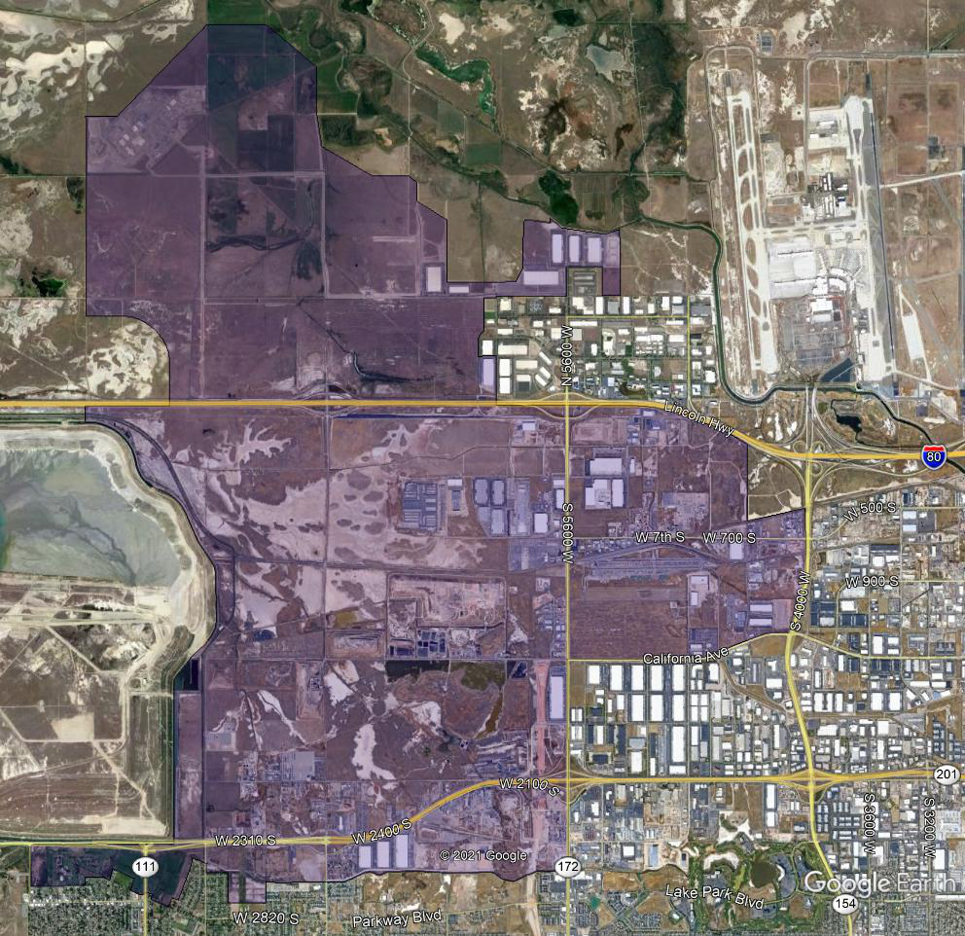

Summary of Project Tasks and Schedule

The tasks associated with this study of the UIP are as follows and shown in Table 1.
1. Implement SAP (spring 2021-fall 2025)
2. Validate field and laboratory results (fall 2021/winter 2025)
3. Analyze data and publish data and annual report (fall 2021/winter 2025)
4. Revise this SAP annually, if appropriate, based on previous findings or changes resulting from ongoing UIP development.
5. Final Report

Table 1. Project Timeline
Task | 2021 |  |  |  | 2022, 2023, 2024 |  |  |  | 2025
 | Months
 | 06 | 07 | 09 | 10 | 04 | 05 | 09 | 10 | 04 | 05 | 09 | 10 | 11 | 12
1.Sample collection (grab and/or composite) | X | X | X | X | X | X | X | X | X | X | X | X
2. Data Validation |  |  |  | X |  |  |  | X |  |  |  | X
3. Data Analysis/Reporting |  |  |  | X |  |  |  | X |  |  |  | X | X
4. SAP review |  |  |  |  | X |  |  |  | X
5. Final Report |  |  |  |  |  |  |  |  |  |  |  |  | X | X

Objectives and Design of the Study
The United States Environmental Protection Agency’s (EPA’s) seven-step data quality objective (DQO) process (EPA, 2006) is used to guide the rationale for the Utah Inland Port SAP. The DQO process defines the type, quantity, and quality of data and establishes performance and acceptance criteria to make sure that the collected data supports the goals of the study.

Specific Objective of the Study

The specific objective of this study is to collect water quality data to characterize the condition of storm water quality associated with the UIP prior to, during and following its development. This will help identify and prioritize management practices needed to offset the increase in impervious surfaces resulting from UIP development. Retention and detention of storm water from impervious areas is key to attenuating sudden discharges that mobilize pollutants and threaten downstream water quality and uses.

Project-level data quality objectives (DQOs) for this study are to collect data of the appropriate type, quality, and quantity to test and improve upon current sampling methods and necessary to support the assessment of water quality impacts and mitigation measures associated with the UIP, including:
- Characterize the quality of storm water within the UIP area:
  - Compare stormwater quality across sites representative of varying land uses and stages of development, including pre-development, active development, and full development.
  - Summarize water quality conditions by comparing water quality information against existing water quality datasets (e.g., related industrial wet-weather monitoring results derived by Salt Lake City and Salt Lake County as part of their MS4 permit requirements.)
  - Track changes in storm water quality and quantity during the course of development (within 5 year study) through the collection of storm event chemistry and flow data.
  - Use storm water quality data to evaluate best management practice effectiveness and provide information on need for additional measures and/or mitigation.
  - Evaluate impacts of stormwater to nearby receiving water quality. For instance, in the case of Goggin Drain, USGS maintains a discharge gage near its mouth to GSL and collects monthly nutrient data.
  - Evaluate the performance of collection methods, such as flow-weighted vs composite sample collection to determine if higher resolution storm event monitoring is warranted.
  - Characterization of presence and relative mass of potential contaminants through the installation of passive sample devices and pressure transducers for estimating storm water flow and pollutant loading.

- Characterize baseline and changes to water infiltration:
  - Track changes in development and percent impervious cover using best available imagery over the course of the study.
  - Perform between site comparisons under different stages of development and at sites over time.
  - Evaluate runoff sampling results against precipitation events and stormwater flow across various study areas.
  - Compare results to existing runoff models.

- Evaluate potential impact to groundwater:
  - Gather historic groundwater data to characterize pre-existing groundwater conditions including impacts from landfills, agriculture, and existing development.
  - Assess groundwater monitoring needs and capacity within the existing groundwater monitoring network. Prepare recommendations for well network improvement and monitoring (if necessary) for evaluation of long-term impacts to shallow groundwater from storm water infiltration and potential impacts to adjacent wetlands.

Data Quality Objectives (DQOs)

DQOs are qualitative and quantitative statements derived from systematic planning that clarify the study objective(s), determine the most appropriate type of data to collect, determine the most appropriate conditions from which to collect the data, and specify the level of uncertainty allowed in the collected monitoring data while still meeting the project objectives (EPA, 2006). Important DQO elements are summarized in Table 2.

Table 2. Data Quality Objectives.construction
Step | DQOs for Utah Inland Port Storm Water Assessment
1. Problem Statement | Development of the UIP is expected to intensify land uses within its project boundaries including large scale commercial facilities engaged in warehousing and shipping goods. To ensure that appropriate measures are implemented to mitigate development impacts on the sensitive wetland environment along the Great Salt Lake, a long term (5 year) monitoring program is proposed to assess current and future water quality conditions of storm water originating from the UIP area arising from destruction, construction, development, and operational activities.  The baseline information collected from this study will be compared to future water quality conditions relative to increases in impervious surface area to identify the effectiveness of best management practices designed to protect water quality as well as identify any potential impacts and appropriate mitigation measures required to offset those impacts.
2. Goal of Study / Decision Statements | Key Question[s]  1. What are the current water quality conditions of storm water in the UIP area and how does it change over time as development occurs? What trends do the water quality parameters indicate?  2. Are there correlations among the water quality parameters and stages of UIP development? If so, how do these correlations relate to on the ground activities such as land clearing, road and building construction?  3. How can correlations between land use activity and storm water quality help identify and locate appropriate best management practices and / or mitigation measures?  Potential Outcomes  Information is adequate to characterize the water quality of storm water over time as land use intensifies from agricultural to industrial and commercial uses.  If information is not adequate to characterize the condition of storm water, DWQ will evaluate results and provide further recommendations on how to improve the data collection process in 2023.
3. Inputs to Decision | The following information will be collected:  Field sampling will be conducted with portable samplers on a continual basis for 7 months of each year when non-freezing precipitation events occur (April-October) at 6 sites. For the 2022 sampling season, passive sampling devices will be installed to provide qualitative estimations of pollutant loading at each site. In addition, installation of pressure transducers will provide valuable information for estimating pollutant loading during storm events.  Water chemistry analytes:  Total Dissolved Solids, Total Suspended Solids, Volatile and Semi-Volatile Organic Compounds, Total metals, and Total Petroleum Hydrocarbons.  Storm water sampling will be conducted at representative locations. Due to the episodic nature of storm water flows, deployment of portable automatic samplers will be required.
4. Study Boundaries | The study area for this project is shown in Figure 1.  Practical Constraints on Data Collection  Permission for sampler deployments will need to be obtained from landowners.  Staff and funding availability will need to be provided.  Availability of field equipment, as well as equipment functionality, may limit some activities.  Weather is a significant constraint for all sampling and monitoring activities. This is because storms can limit the ability to safely conduct sampling and measurement activities in the study area.  The presence of ice and/or lack of water could limit the ability to collect samples.
5. Decision Rules | The data collected under the scope of this SAP will support the goals of the study. They will guide the DWQ on how to decide whether the available data are sufficient to characterize changes in storm water quality associated with the UIP, assess the effectiveness of best management practices used, and determine appropriate measures to mitigate any negative effects.  If information is not adequate the DWQ will evaluate results and provide recommendations for the 2023 SAP.
6. Acceptance Criteria | Precision—field replicates will be collected for all water chemistry parameters at least once per each site per monitoring season.  Accuracy—special efforts will be made to minimize contamination of water chemistry samples through proper collection of field samples, monitoring of sampling bottle blanks, and the use of appropriate laboratories for analysis.  Representativeness—the sampling locations have been selected based on a review of aerial photos. The sites were chosen due to their accessibility and setting along major drainages within the UIP. Sites were chosen to encompass potentially unique characteristics of different conditions, such as water sources and potential pollutant inputs. Field sampling will occur following appropriate sample collection procedures as described in SOPs for each method. Site photos and field notes will be collected at each site and can be used to describe any unusual conditions that may occur.  Completeness—to ensure the sampling goal of 100 percent completeness at the end of the season, we will use field reconnaissance to verify that sites have the proper hydrologic conditions.  Comparability—all field sampling and analytical procedures will be completed following both previously tested and newly developed SOPs for each metric. They will be performed by the same field crew to the extent possible throughout the sampling season.  DWQ’s QAPP specifies the minimum QA/QC objectives for sample measurement.
7. Sampling Plan and Design | The baseline sampling program includes the following:  Field observations, collection and analysis of water and substrates for chemical analysis, and physical attributes, as appropriate.

Sample Design

Water Quality Characterization
The objective of this SAP is to assess the condition of water quality before, during and after UIP development through the analysis of chemical data collected from 6 monitoring locations (Figure 2). Samples will be collected from storm drain channels in developing areas of the UIP to assess changes in water quality over time. Monitoring locations are strategically placed within areas that are currently under development, or will be in the near future. As described in objective 2, the gradient of development across sites will be characterized using aerial imagery.

Figure 2. Utah Inland Port Storm Water Monitoring Sites.
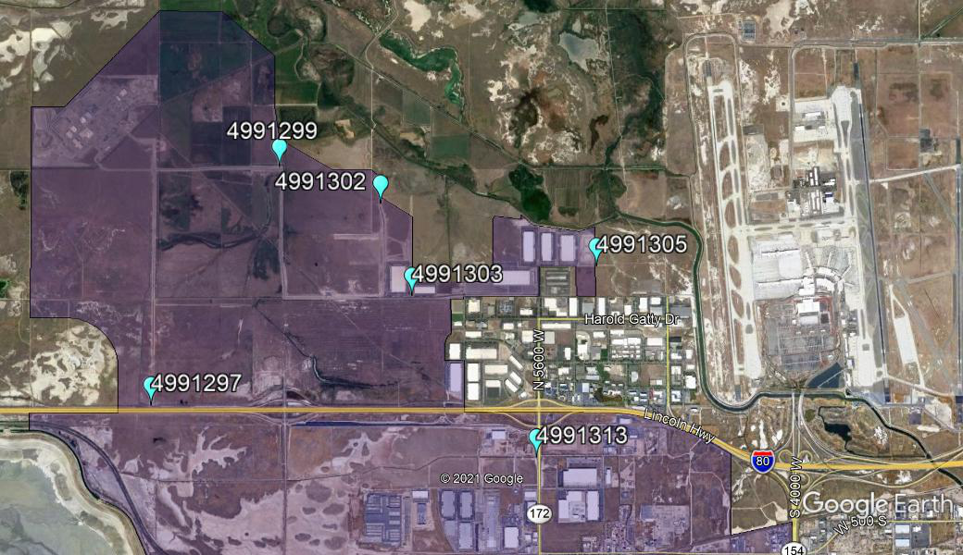

Table 3 summarizes the list of sampling sites, their approximate drainage area within the UIP, and predominant land use within that area. All of these sites are open channels but have different characteristics depending on their drainage area and level of development within them.

Four storm water drainage channels along the northern periphery of the study area (4991299, 4991302, 4991303, and 4991305) flow towards Goggin Drain while the two to the south (4991297 and 4991313) flow west towards Lee Creek. The channels receive storm water flows from the streets they parallel and the adjacent developed areas that discharge to them. Based on the current level of construction activity these areas are anticipated to be largely converted from agricultural to industrial and commercial uses within the next several years.

Sample locations also differ with respect to current land uses within their drainage areas (Figure 3).
In the study area, there are existing land use characteristics that are potentially altering ambient water quality conditions. Most of the upstream drainage areas are influenced by farming and grazing agricultural activities, although the relative intensity of these activities differs through the UIP study area. A retired landfill is also present and leaching from these areas could influence the water quality of shallow ground water and subsequently storm water sample results. Some sites were selected with differing land use characteristics to help differentiate alteration of water quality resulting from UIP development from those caused by other current and historical land uses. The drainage area for 4991297 is the site currently least influenced by human activity (stormwater from I-80 and low intensity agriculture) and can be considered to reflect reference conditions for purposes of this investigation. Finally, there are areas where land development is largely complete and other areas where development is ongoing.

Figure 3. Monitoring Site Catchment Areas
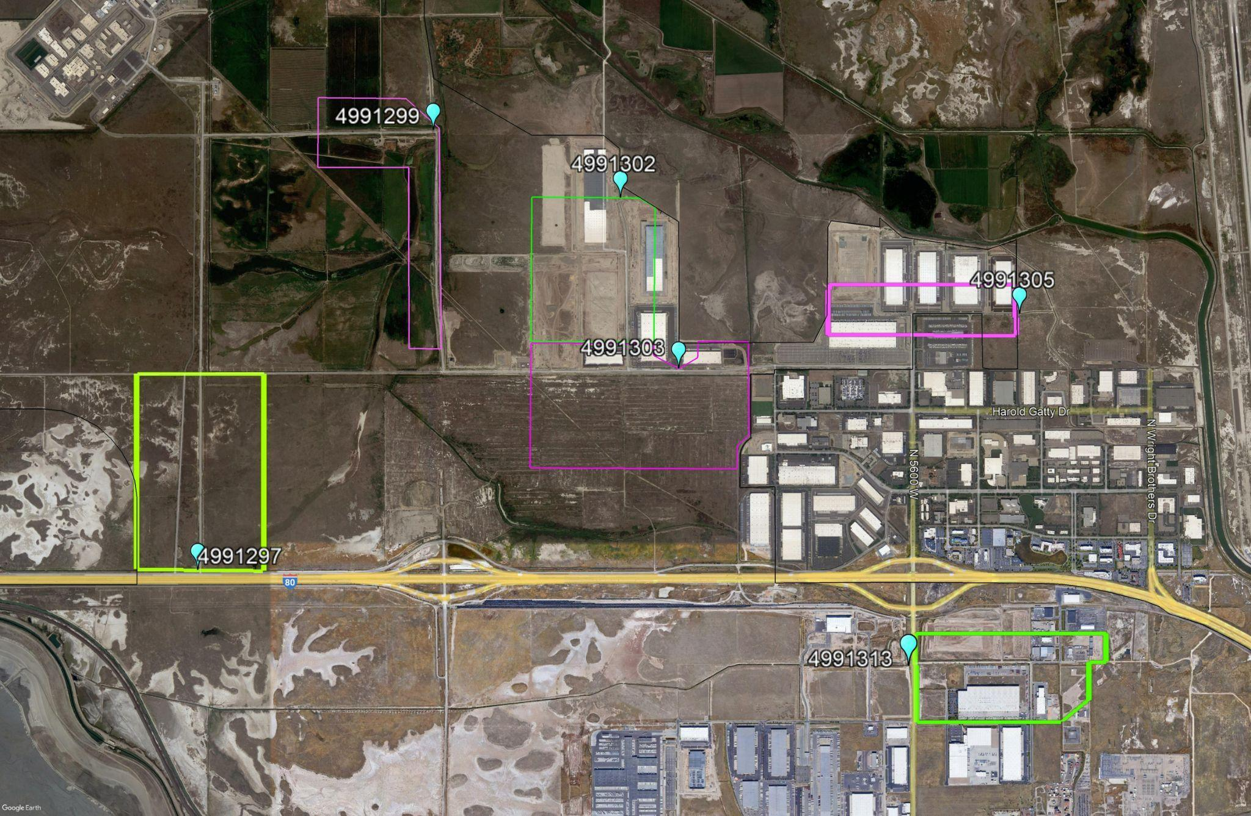

Site descriptions and selection rationale

While the entire UIP area is slated for development, the sites selected for this study represent various stages of pre-development, active development and post-development and are intended to provide multiple opportunities of comparing storm water quality between sites to discern potential impacts to water quality and pollutant loading. Furthermore, these sites will also be compared to MSGP benchmarks and data from SLC and SLCo wet-weather monitoring at Lee Drain which should be representative of mixed industrial/commercial storm water runoff in the vicinity.

4991297 Storm Drain Channel at 8000 W North Temple

This site is intended to capture conditions minimally impacted by development with the exception of localized roads and roadside conveyances. The dominant land-use in the drainage area is existing low-intensity agriculture. If this location remains undeveloped during the study period, it may represent a good reference site for comparison to sites under active or post development. Judging from the limited number of qualifying runoff events during the 2021 monitoring season, this site would be indicative of limited impervious surface development and high permeability. Runoff from this parcel drains into a ditch which flows to the west to Lee Creek.

4991299 Storm Drain Channel at 7200 W and 1300 N

This site is also in early stages of development while still dominated by low intensity agriculture uses. In addition, a major transportation artery of the UIP to the northwest dominates the borders of the drainage area. Discharge from this area flows north into the Goggin Drain.

4991313 Storm Drain Channel at 150 S 5600 W

This site is representative of older fully developed industrial/ commercial land use and originates from the area east of 56th West. For the duration of the study period, this site will represent a more fully developed industrial/commercial site for comparison with more recently the developing and newly developed sites over time. Discharge from this area flows west through a ditch and ultimately to Lee Creek.

4991305 Storm Drain Channel at end of John Cannon Dr

Similar to 4991313, this site represents a more recently developed area within the UIP with some potential for development of a parcel directly south s adjacent to the Fedex facility. This area discharges to the east via open canals and into the Goggin Drain and includes a small portion of pre-existing industrial use outside the UIP. operated by Fed-Ex but this is not expected to representativeness of data due to existing controls

4991302 Storm Drain Channel at 1100 N 6550 W

As of April 2022, this site is likely to capture the most currently active construction and development activities in the study area as it is located in an area of large warehouse and road development with multiple retention basins and drainage ditches feeding into the sampling location. It is also located close to and flows into the Goggin Drain to the north.

4991303 Storm Drain Channel at 6000 W 700 N

This location is also under active development located just south of 4991302, and includes a major road (700 North bisecting the drainage east to west. In addition, the area includes a portion dominated by a large undeveloped area to the south which includes the historic North Temple Landfill that closed in 1979 and has undergone extensive characterization studies to initiate a phased re-development of the site under the Voluntary Cleanup Program anticipated to begin in summer 2022.

Table 3. Utah Inland Port Monitoring Sites
Site ID | MLID | Site Name | Latitude | Longitude | Drainage Area (ac) | Land Uses
REF | 4991297 | Storm Drain Channel at 8000 W North Temple | 40.77155 | -112.08308 | 144 | Low intensity agriculture
AG1 | 4991299 | Storm Drain Channel at 7200 W and 1300 N | 40.79863 | -112.06399 | 157 | Developing Industrial/Low Intensity Agriculture
NEWDEV1 | 4991302 | Storm Drain Channel at 1100 N 6550 W | 40.79447 | -112.04880 | 204 | Developing Industrial
NEWDEV2 | 4991303 | Storm Drain Channel at 6000 W 700 N | 40.78396 | -112.04408 | 316 | Developing Industrial
OLDDEV1 | 4991305 | Storm Drain Channel at end of John Cannon Dr | 40.78732 | -112.01642 | 109 | Developing Industrial
OLDDEV2 | 4991313 | Storm Drain Channel at 150 S 5600 W | 40.76567 | -112.02543 | 180 | Developing Industrial
Receiving water | 4991426 | Lee Creek 0.6 mi north of frontage road and 1.23 mi west of I-80 xing (Downstream of UIP) | 40.78019 | - 112.13924 | NA | NA
Receiving water | 4991560 | C-7 DITCH AT 8000 WEST | 40.75161 | -112.08189 | NA | NA
Receiving water | 4991300 | Goggin Drain at USGS Gaging Station 10172630 | 40.81661 | -112.10078 | NA | NA
Receiving water | TBD | Goggin Drain below Surplus Canal Diversion | 40.793000 | -112.10078 | NA | NA

With the exception of receiving water sites, sites listed in the sequence composite samples will be collected following a qualifying storm event. Composite storm water samples will be collected from portable samplers from April through October and are contingent on precipitation events of at least 0.1 inch to generate runoff. Qualifying storm events that generate runoff for sample analysis will include those greater than 0.1 inch and at least 2 weeks from the previously measurable—greater than 0.1 inch rainfall—storm event. Generally, 72 hours between storm events is considered the minimum interval for samples to be considered representative of storm water quality (EPA 2009). A two week time interval was identified for this study however to ensure sampling of discrete storm events and to preserve sufficient financial and analytical resources to complete the study. Grab samples will also be collected during select storm events at least twice each year for comparison with autosampler results. Samples will be collected as a composite throughout the duration of the runoff event on a flow weighted basis. Receiving waters will be sampled routinely on a monthly basis and additional samples during storm events will be collected as needed.

Measured Storm Water Quality Parameters
Water quality monitoring activities will aim to understand the temporal and spatial condition of storm water within the UIP area. Storm water samples will be characterized by a suite of select parameters that are responsive to environmental conditions within their contributing area and will help managers understand the temporal and spatial condition of storm water before, during, and after Utah Inland Port development.
DWQ’s resources will be dedicated to collecting environmental samples that describe the condition of storm water flows. This data will be critical in benchmarking the present condition and identifying changes in water quality associated with the development of the Utah Inland Port project. This section provides a detailed summary of the approach the DWQ will use beginning in 2021.

Sample Collection

Automatic and discrete sampling:
Composite storm water samples will be collected from April through October during qualifying storm induced runoff events through the use of portable samplers. Water chemistry samples will help determine the temporal and spatial conditions of these waters before, during and after project development. Table 4 shows the chemical analytes that will be analyzed from samples collected at these sites, allowable hold times of when samples must be analyzed, and the estimated budget for analysis costs. Table 5 shows the sampling equipment required to complete this monitoring effort and the estimated budget for acquiring this equipment. Sampling procedures, analytical methods, and quality assurance requirements are found in the QAPP in Appendix D.

Table 4. Parameters to Be Measured, Hold Times, and Analysis Budget.
Description | Collection Method | Details | Parameters | Analytical Hold Times | Cost per sample* | Total Cost**
General Chemistry | Portable Sampler Composite Sample/Grab | One 500 mL plastic bottle unpreserved | Total suspended solids  Volatile suspended solids  Total dissolved solids | 7 days  7 days  7 days | $15  $20  $15 | $2,160  $2,880  $2,160
Total Nutrients | Portable Sampler Composite Sample/Grab | One 500 mL plastic bottle with H₂SO₄ preservative to pH <2 | Ammonia  Nitrate/Nitrite  Total Phosphorus  Total Nitrogen | 28 days  28 days  28 days  28 days | $38  $13  $40  $53 | $5,472  $1,872  $5,760  $7,632
Total Metals | Portable Sampler Composite Sample/Grab | One 250 mL plastic bottle with HNO₃ preservative to pH <2 | Zinc  Lead  Cadmium  Arsenic  Copper  Selenium  Aluminum  Beryllium  Antimony  Nickel  Silver  Mercury  Cyanide | 6 months  6 months  6 months  6 months  6 months  6 months  6 months  6 months  6 months  6 months  6 months  28 days | $108 for all | $15,552
Organics | Portable Sampler Composite Sample/Grab | 1L Glass | TRPH, DRO/ORO, PAHs |  | $350 | TBD
 | Grand Total of Estimated Cost for Analysis |  |  |  |  | $43,488
 | * Costs are provided for estimating purposes only and do not necessarily reflect current rates at private analytical laboratories.
 | ** Total sample analysis estimate assumes 2 composite portable sampler storm water samples collected each month (April, May, September, and October) at all 6 monitoring locations for three years for a total of 144 samples analyzed.
 | Note: Additional opportunistic storm sampling is not included in this budget but will amount to ~$650 per site/visit.

Table 5. Portable Sampler Equipment Budget (Capital costs for reference only as part of 2021 budget)
Description | Quantity | Unit Price | Total Cost
Portable Sampler  Includes controller, top cover, center section, base, distributor arm, instruction manual, and pocket guide. | 6 | $2,974.09 | $ 17,844.54
Signature® Area Velocity flow meter system includes base meter, TIENet 350 area velocity sensor with 10m cable, manual, and pocket guide. | 6 | $3759.00 | $22,554.00
CDMA LTE cellular modem with magnetic mount antenna for Signature® meter. | 6 | $883.87 | $5,303.22‬
Sample bottles  24-bottle Configuration for 3700 Full Size Portable Sampler. Includes 24 polypropylene 1-liter bottles with caps, bottle retaining ring, and two pump tubes. | 6 | $202.27 | $ 1,213.62
Solar Panel Assembly and 12V Regulator Controller  Includes PLM50P -50-Watt Solar Panel with 20' lead and PM50U Pole Mount Bracket | 6 | $345 | $ 2,070‬.00
Miscellaneous cables, tubing, strainers, and couplers | 6 | $248.90 | $ 1,493.4‬0
Sampler Housing | 6 | $1,636.25 | $ 9,817.50
Grand Total |  |  | $ 60,296.28

Discharge measurements
Stormwater discharge is a critical component to understanding the effect of changes in land-use and impervious cover and its potential effect on loading to receiving waters. Furthermore, discharge measurements in combination with pollutant concentrations allow the estimation of pollutant loading which is an important measure of the magnitude of the storm water event and impact to receiving waters. Over time, unless mitigation measures are in place to offset impervious cover, discharge from developed and developing areas is likely to increase and will be a critical measure for evaluating this project. During the 2022 monitoring season, DWQ will include the programming of sensors for the estimation of discharge during storm events. At the time of this SAP version, staff are determining the best options for implementing this addition and will update the SAP accordingly once determined since not all locations are suitable for discharge estimation.

Data Analysis

Objective 1: Stormwater evaluation

To meet the objectives set out in this SAP and the annual reporting requirements set in rule, several key data analysis steps will be taken to ensure the UIP is properly assessed and feedback to project managers and developers is provided.

In the absence of applicable water quality benchmarks, staff will primarily evaluate the site-to-site differences in water quality relative to upstream characteristics such as status of development, land-cover, and other management activities relevant to storm water runoff as determined in Objective 2. As mentioned elsewhere, there are sites that could represent reference conditions (undeveloped) and control sites (fully developed) which will be helpful in delineating the impacts of ongoing activities. While these reference and control sites may not be equal in size or land cover, they are likely representative of background conditions in the area for comparative purposes. Coupled with ongoing aerial tracking of changes in impervious surfaces and status of construction, timing of storms can be linked to activities over time in each of the catchments. Furthermore, these results may be compared against SLC and SLCo wet weather monitoring results as representative of localized weather and runoff from developed mixed industrial stormwater sites.

Previous work revealed that each site receives variable amounts of stormwater. As a result, staff will also compare sites using flow-weighted pollutant concentrations. This is typically accomplished by calculating pollutant loads, or the total mass delivered by each flow event; however, these calculations require accurate measures of flow, which may not be possible at all stormwater locations. As a result, DWQ will also explore other ways to normalize water quality measures, such as rainfall using SLC and SLCo wet weather monitoring data.

Downstream Transport of Pollutants
The stormwater monitoring locations will allow the amount of pollutants leaving IP locations to be quantified and compared among site locations and identify which pollutants have the greatest potential to harm aquatic life uses downstream. However, many of the interconnected ditches that convey the water to potentially sensitive wetlands downstream are very low gradient and sometimes linked to water infiltration basins. Many of the pollutants delivered by IP storm water may never reach sensitive wetlands downstream. Understanding the transport of pollutants to these wetlands will be challenging, but estimating the ultimate fate of IP storm water pollutants is important because the protection of the designated uses of the waters is the ultimate objective of all water quality regulations associated with IP storm water.

Efforts are underway to better understand the ultimate fate of IP storm water for other planning efforts (Jacobs Engineering, Denbleyker, Pers. Comm.) and these data will be incorporated into water quality monitoring reports once the complex flows downstream of IP developments are better understood. These estimates will require information on the amount of flow necessary to transition for the baseline stagnant conditions in most of these ditches and also estimates of evapotranspiration. Accurate estimates of downstream transport will be better understood over time. At a minimum, annual monitoring reports will need to emphasize that measured pollutants from IP monitoring locations overestimate threats to downstream waters.

Furthermore, the USGS gaging station and associated data collected there (and at other receiving water sites), may also provide additional context with respect to receiving water quality. That said, given the upstream impacts to Lee Creek/C-7 Ditch and Goggin Drain, which is essentially a spur of the Surplus Canal and Jordan River, discerning an instream effect may be precluded by existing stormwater pollution loading. However, since the Goggin Drain and Lee Creek are important sources to adjacent wetlands and GSL, this dataset will be included in the data analysis and final report because it will provide context for the amount of pollution from IP storm water relative to other storm water sources upstream.

Objective 2: Changes to Water Infiltration from IP Development

As part of a general analysis of land-use changes in the UIP, staff will obtain high resolution satellite imagery to track development and estimate impervious cover as a baseline for the beginning of the study and through time. This component will assist in interpreting changes in water quality and quantity at established stations as the IP continues to be developed. Coupled with data from precipitation events, these data will be used to establish the baseline gradient of conditions across the sites as part of the design in objective 1 and quantify those changes through time; ideally annually. Additionally, the data will be valuable to project managers in estimating runoff and determining sampling frequency and scenarios at the beginning of each sampling period.

Objective 3: Groundwater evaluation
Initially, DWQ will work with WMRC and DERR staff to compile and interpret existing groundwater information. This may be helpful in interpreting runoff and receiving water data in terms of background and historic contamination from sources such as Kennecott and the historic landfill.

Project Team and Responsibilities

As defined by DEQ’s Quality Management Plan (QMP), any monitoring activity conducted or overseen by DWQ must have a Designated Project Manager (DPM), a staff member who is responsible for a specific project and has immediate managerial or technical control of the project. The DPM is responsible for specifying the quality of the data required for each project and initiating corrective actions when quality control is not being met. The DPM may also be a program manager. The DPM is responsible for designing monitoring strategies, setting project-specific data quality objectives (DQOs), and developing project-specific SAPs. DPMs are responsible for making sure all personnel involved with the project are briefed and/or trained on the procedures to be used.
Any monitoring activity conducted or overseen by DWQ must also have a Field Project Manager (FPM). The FPM will be responsible for checking the field note forms, data collection sheets, field lab sheets/Chain of Custody (COCs) forms for completeness. These sheets will be checked for completeness within 72 hours (or within a week of sample collection). Field notes will be filled out in the field for all sites whether samples were taken. Any information missing from field forms will be verified by the field crew. A list of missing samples or data will be provided to the DPM for data tracking purposes. After the data sheets are reviewed for completeness, all data will be scanned and entered into electronic worksheet files for storage in the "U:\INFODATA\Sampling\Project Sampling\STORMWATER_PORTABLE_SAMPLERS\UIP_LAB_rawdata" folder on the network drive which is backed up daily. When entered into an electronic worksheet, the person who enters the data will double check the information for errors and save the files, so they can be reviewed by the FPM and/or QA Project Manager for quality.

Implementation of the SAP will require an interdisciplinary effort. The team that will implement the SAP consists of various members from DWQ. Table 6 lists and identifies the key project personnel and their responsibilities. The overall efforts will be coordinated closely with other ongoing research groups and stakeholders. In addition, DWQ staff will work with other partners, including the Salt Lake City Storm Water program and Jacobs Engineering to integrate aspects of their ongoing planning and analysis efforts.

Table 6. Project Team Members and Contact Information.
Title | Name | Affiliation | Key Tasks or Responsibilities | Contact Information
 |  |  |  | E-mail | Phone
Designated Project Manager | James Harris | DWQ | Oversees direction of project, data analysis, reporting | jamesharris@utah.gov | 801-541-3069
Storm Water Lead | Carl Adams | DWQ | Storm Water Program Lead | carladams@utah.gov | 385-382-6685
Project Support | Jeff Ostermiller | DWQ | Technical Support and SAP Development | jostermiller@utah.gov | 801-258-1611
Field Project Manager | Alex Anderson | DWQ | Directs day-to-day work of project, performs field data collection | aranderson@utah.gov | 435 760 4286
Quality Assurance (QA)  Project Manager | Toby Hooker | DWQ | Oversees QA for Division, responds to QA issues, supervises monitoring team | tobyhooker@utah.gov | w: 801-536-4289

Field Activities
Field operations will be overseen by Alex Anderson, an experienced member of the DWQ Monitoring Section.

Field/Lab Sheets and Chain Of Custody Forms
Preprinted lab sheets, Chain of Custody forms, and the Portable Sampler Field Form (Appendix A, Appendix B and Appendix C respectively) will be used on the monitoring run. Hard copies of field notes are kept in a binder at DWQ. All field and lab data and paperwork will include a unique Trip ID: UIP (YYMMDD) or UIP 210314, which reflects a sample trip that began on March 14th, 2021. Composite samples retrieved from the portable samplers will be designated as Sample Type “COMP”. The Project Code for this study will be 303.

Field Sampling Methods
This section summarizes the methodology for environmental sample collection at the sites and incorporates the DQOs outlined in previous sections, the safety precautions, and workflow.

Field protocols
This section provides a brief overview of the field sampling activities to be performed at each site. Specific instructions, including required equipment and procedures, are located in the SOPs.

SOP For Portable Samplers

https://documents.deq.utah.gov/water-quality/monitoring-reporting/sop/DWQ-2020-008444.pdf

SOP For Chain of Custody Samples

https://documents.deq.utah.gov/water-quality/monitoring-reporting/sop/DWQ-2019-001920.pdf

Health and Safety
Safety must be a primary concern at all times and in all sampling situations for field sampling personnel. In any marginal or questionable situation, monitoring personnel (monitors) are required to assume worst case conditions and use safety precautions and equipment appropriate to that situation. Monitors who encounter conditions which in their best professional judgment may exceed the protection of their safety equipment or may in any way represent a potential hazard to human health and safety, should immediately leave the area and contact their supervisor.

There must be a minimum of two sampling personnel present in the field. To avoid direct contact with contaminated water, latex or rubber gloves will be worn when sampling surface water. Monitors will wash hands and arms thoroughly with bacterial soap after sampling or before eating and drinking. Monitors should be familiar with basic first aid and cardiopulmonary resuscitation (CPR).
Monitors are strongly encouraged to carry a cell phone. Monitors will inform a supervisor when they leave for the field and their estimated time of return. The supervisor will initiate an emergency action plan if the samplers have not returned to the office within the allocated time. To avoid unnecessary worry and concern, samplers will call the office if they are behind schedule.

Safety Precautions and Plan
Field personnel will take appropriate precautions when operating watercraft and working on, in, or around water; possibly steep or unconsolidated banks; or edges of ponds. All field crews will follow appropriate safety procedures and be equipped with safety equipment such as proper wading gear, gloves, first aid kits, cellular phone, etc. All boats should be equipped with safety equipment such as personal floatation devices, oars, air horn, etc. Utah’s Boating Laws and Rules shall be followed by all field personnel.
Field personnel will be aware that hazardous conditions potentially exist at every water body. If unfavorable conditions are present at the time of sampling, it is recommended for staff to reschedule the sample visit. If hazardous weather conditions arise during sampling, such as lightning or high winds, personnel should cease sampling and move to a safe location.

Most often, sample bottles are prepared by the State Lab and already contain preservative. During packing and handling of bottles, the field personnel must be careful and should confirm that caps are tightly sealed in order to avoid contact with preservative (acid). If minor skin contact occurs, field personnel should rinse with copious amounts of water. If major skin or internal contact occurs, affected personnel should seek medical attention.
Monitors should take care to reduce the possibility of contracting diseases carried by insect vectors such as West Nile virus (mosquitoes) and tularemia (horse flies). Other factors to consider are dehydration, weather exposure, stings, and potential site access issues such as barbed-wire fences, broken glass, steep slopes, and mud.

Equipment

Equipment Testing, Inspection, and Maintenance
DWQ field monitors will inspect all sampling equipment before every sampling event. Equipment maintenance will be scheduled and completed based on these inspections and review of the collected data. The QA Project Manager will regularly review all calibration and maintenance records, so the minimum required maintenance occurs. Detailed procedures for the maintenance of equipment are provided in the corresponding SOPs.
The designated laboratories for this project will be responsible for and expected to follow their standard procedures for preventative/unscheduled maintenance, calibration, and correction action for all laboratory instruments. DWQ is not responsible for the maintenance of the designated laboratories’ equipment.
The frequency of collection and analysis of quality control checks, including field duplicates and equipment blanks is outlined in Table 7 below.

Table 7. Sample Quality Control.
Parameter | QC Check | Frequency | Acceptable Range | Correction Actions
Field Duplicates | Repeatability of sample collection and analysis, and measure of sample heterogeneity | 1/10 sites | Relative percent difference of ± 20% | Notify staff if missing; audit and train; decide to allow or reject data
Equipment Blank | Cross contamination between samples | 1/ 10 sites or at end of sampling day | Non-detect | Notify staff, repeat procedure, find contamination source, decide to accept or reject data

Laboratories and Sample Handling Procedures

Laboratories
Water chemistry samples will be analyzed by the Chemical and Environmental Services Bureau of the State of Utah’s Public Health Laboratories (hereafter referred to as the State Lab). The State Lab maintains an in-house QAPP, available from the QAO (Toby Hooker). In addition, organic analysis will be performed by American West Analytical Lab.

Table 8 summarizes the laboratory, the analyses conducted, and point of contact for this study.

Table 8. Analysis and Laboratory.
Analysis | Laboratory | Contact | Phone
Water Chemistry , Nutrients and Metals | UPHL | David Dick | 801-965-2405
Organics | AWAL | Kyle Gross | 801-262-7299

Sample Handling
It is the responsibility of the field crew to coordinate with laboratory staff to obtain their own sample bottles at least one week in advance. Samples should not be shipped or delivered to the labs unless they have been informed two days in advance. Water chemistry samples will be stored in coolers in the field or in refrigerators at the TSC when not in the field. After sample collection and compilation, it is the responsibility of the field crew to turn in samples to the laboratory for analysis.

Sample bottles used in this study need to be handled with care in order to protect the integrity of the sample. All bottles and paperwork shall be reviewed for discrepancies and corrected before leaving samples in the laboratory’s custody.

DWQ’s laboratory coordinator, Toby Hooker, works directly with UPHL Sample Receiving and analytical staff regarding water samples and sample data submitted by DWQ. Ryan Parker is the database manager and will coordinate data management practices and storage. All data results from the laboratory will be reviewed and stored by the database manager. This includes chemistry data master logs, electronic lab sheets (from submitted samples), and analysis reports. Data from water samples take approximately 4-6 weeks from submittal to reporting.

Data Management

Data Review and Validation
DWQ’s Designated and/or Field Project Manager will be responsible for receiving the lab and field data sheets, checking for omissions in identification, decimal placement, dates, times, units reported, and comments. Water quality technical staff collecting data will be contacted immediately if there are data gaps or if scheduled sampling times were missed.

It is the water quality technical staff’s responsibility to evaluate raw data generated by the contract laboratories for appropriate data summary, data quality, and accuracy. All data will be reviewed and reported in units specified at the detection level of the analysis methods used. To reduce data point loss, data that is reported as “less than” detection level will be considered in subsequent analyses by the Designated Project Manager at a value of 1/2 the detection level. Once data is generated, it will be compiled in a database file. During this data transfer, the information will be reviewed and verified in accordance with data quality objectives.
Data generated in the laboratory will be validated by performance checks such as duplicates and blanks. Data will be reported in the units that have been designated to each parameter in the Analytical Methods, Holding Times, Parameters, and Sample Collection Methods section tables. Scientific notation will be used, and significant figures will correlate with detection levels.

Data Management and Analysis
DWQ staff proficient in water quality monitoring will organize all lab reports and field data. DWQ Project Manager will be responsible for analyzing the data and preparing, as necessary, annual reports. The findings of the annual report will be utilized to determine if the goals and objectives of the monitoring program are being met and what, if any, modifications to the sampling analysis plan are necessary.

Quality Control
QA/QC samples will be collected as part of DWQ’s monitoring run. It will consist of an Equipment Blank, Trip Blank and a replicate sample. A Trip Blank will only be collected when a VOC and/or an SVOC sample is collected at the beginning of the run by filling deionized water in the appropriate bottles. The equipment blank for the portable samplers will be collected once per sample retrieval trip in the field to ensure no contamination from the equipment between samples. The equipment blank will have an assigned MLID 4991307 EQUIPMENT BLANK-Inland Port Stormwater Monitoring and will be treated identically to the samples collected in the field.

References

1. DWQ. 2014. A Great Salt Lake Water Quality Strategy. State of Utah, Department of Environmental Quality, Division of Water Quality (https://documents.deq.utah.gov/water-quality/standards-technical-services/gsl-website-docs/gsl-wq-strategy/DWQ-2019-000535.pdf)

2. EPA. 2006. Guidance on Systematic Planning Using the Data Quality Objectives Process. EPA QA/G-4, EPA/240/B-06/001, U.S. Environmental Protection Agency, Office of Environmental Information, Washington DC.

3. EPA. 2009. Industrial Stormwater Monitoring and Sampling Guide. EPA 832-B-09-003, U.S. Environmental Protection Agency, Office of Water, Washington D.C.

Appendices

Appendix A: Lab Sheet

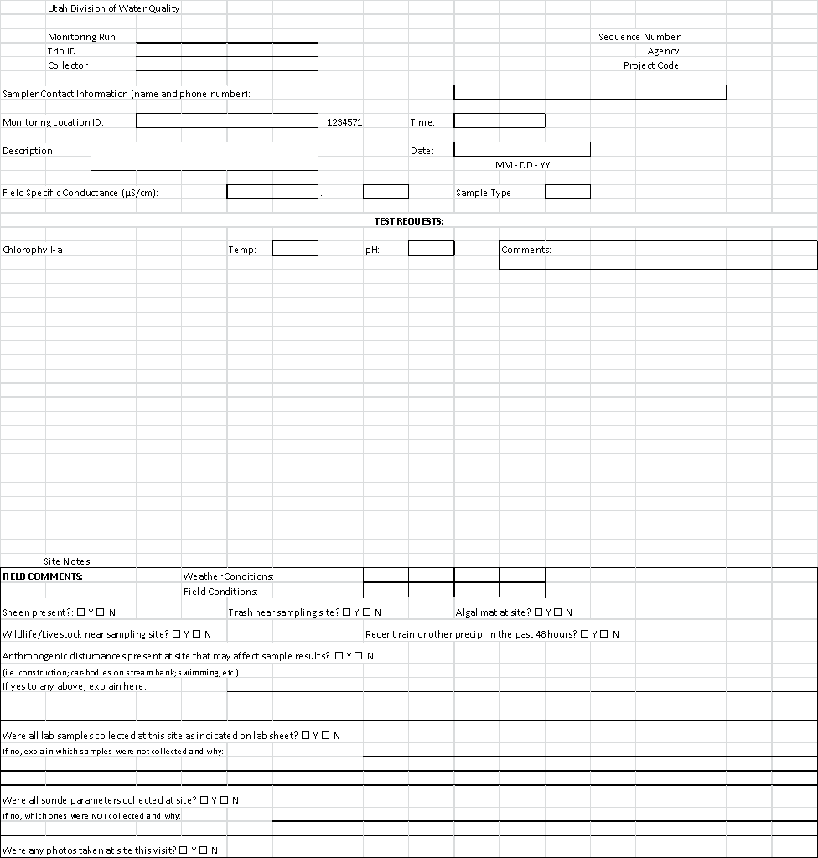

Appendix B: Chain of Custody Forms
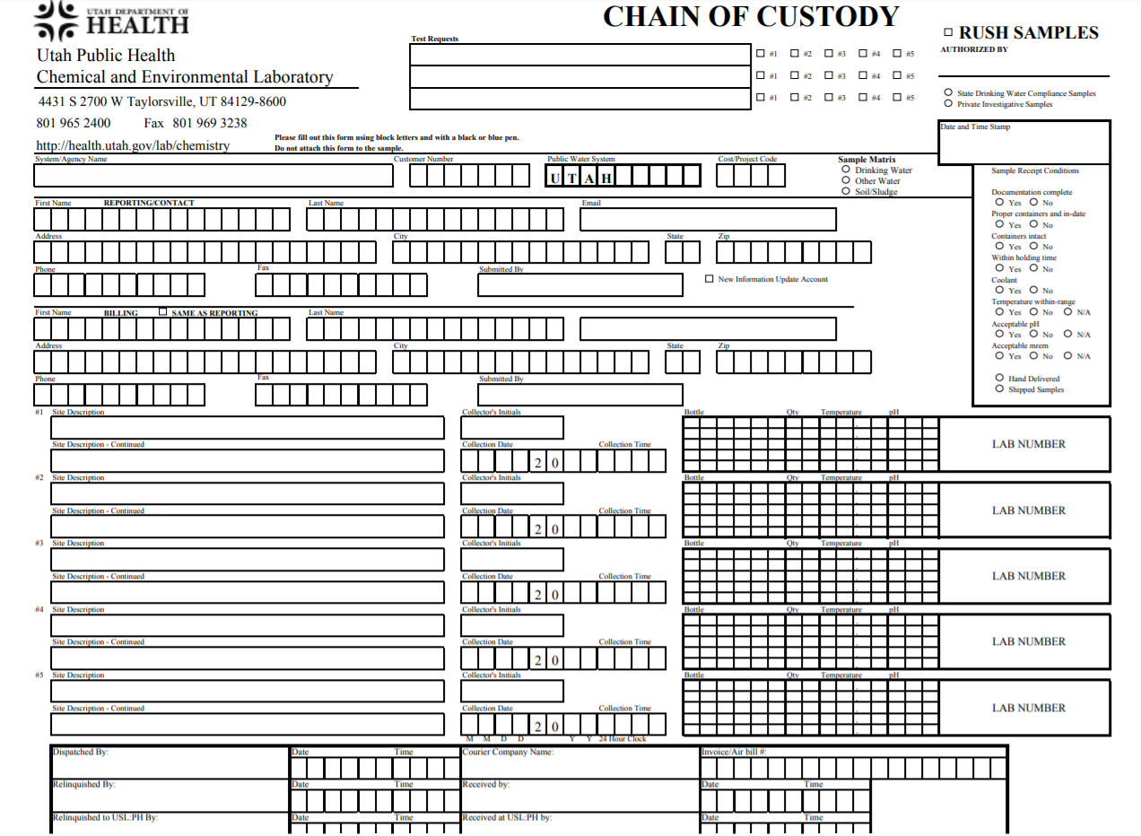

Appendix C: Portable Sampler Field Form
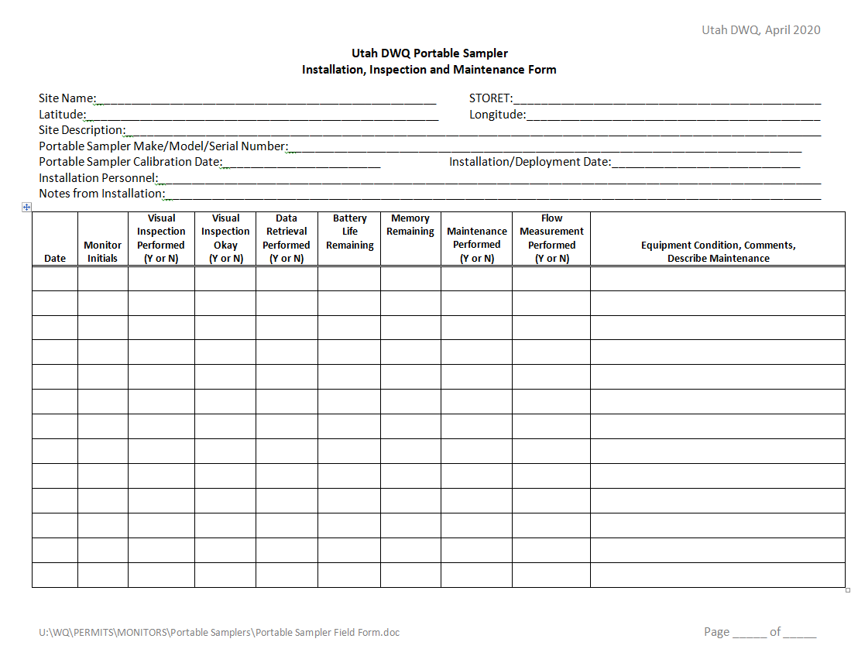

Appendix D: Quality Assurance Project Plan

https://documents.deq.utah.gov/water-quality/monitoring-reporting/sop/DWQ-2019-001869.pdf

Appendix E: Revisions

9/21/2020 Updated Table 3 by removing monitoring location 4991430, Lee Creek at I-80 Crossing and added MLID 4991426, Lee Creek 0.6 mi north of frontage road and 1.23 mi west of I-80 xing (Downstream of UIP). New site captures runoff from frontage road and is now behind a locked gate and safter location with DWQ access per agreement with Rio Tinto.

1/27/2021 Updated Table 1 by extending for one year as deployment of portable samplers was not completed until fall of 2020 due to logistical challenges.

Changed qualifying storm event frequency from at least 72 hours to 4 weeks from the previously measurable storm event (p. 7) to minimize the influence of previous storm events on sample results.

Updated Table 3 by removing monitoring locations 4991650 (Kersey Creek AB Magna WWTP), 4991297 (West Branch Brighton Canal at T1N, R2W, Sec. 28 NE corner), 4991305 (West Branch Brighton Canal at North Temple Frontage Rd xing), and 4991295 (North Point Consolidated Canal below confluence with West Branch Brighton Canal (Upstream of UIP)) and replaced with 4991340 (Goggin Drain at USGS Gauging Sta No 10172630), 4991299 (Storm Drain Channel at 7200 W and 1300 N), 4991302 (Storm Drain Channel at 6500 W 1100 N), and 4991303 (Storm Drain Channel at 6000 W 600 N). The replacement of upstream sites with downstream sites will more effectively capture both localized (storm drain channels) and area-wide (Lee Cr, North Point Canal, and Googin Drain) water quality trends and more effectively utilize resources.

4/15/2021 Sampling Design section, including Table 3 updated with descriptions of monitoring sites including contributing area within the UIP, and land uses. Table 4 updated with allowable hold times of when samples must be analyzed per parameter.

6/8/2021 Sampling Design section, including Table 3 updated with descriptions of three new monitoring sites (4991297, 4991305, and 4991313) including contributing area and land uses. These three sites replace monitoring sites on Lee Creek, North Point Consolidated Canal, and Goggin Drain which were not as representative of storm water quality.

Removed grab sampling and related field analysis protocols from study. With exclusive use of storm drain channels for monitoring purposes, grab samples and attendant field measurements are not representative of critical first flush storm water conditions and do not effectively further study goals and objectives.
Increased sampling frequency from once every 4 weeks to once every 2 weeks to better capture the episodic and variable nature of precipitation events. Extended sampling season across all months (April-October) when non=freezing precipitation occurs.

